


Gloucestershire Nature Recovery Network Mapping Methodology
Version 4.1
November 2025

Change log
Version | Date | Changes
Production of the Gloucestershire NRN | Jan 2019
Gloucestershire Nature Recovery Network Mapping Methodology v2 | Nov 2022 | Added intro explaining reason for NRN, updated habitat layer creation section for rerun. Farmland birds added annex.
Gloucestershire Nature Recovery Network Mapping Methodology v3 | June 2023 | Habitat data source table updated to those used for updated NRN rerun and reliability score column included. Habitat layer creation method updated. Amended wetland methodology with new version (wetland v2). Combined prioritised arable network areas included as requested by Worcestershire
Gloucestershire Nature Recovery Network Mapping Methodology v4.0 Technical | Nov 2025 | Added clarification for wood core areas (isolated areas <0.25ha are not counted as core). Added explanation for WPP correction to habitat layer. Added altered Agri Land Class weightings to tables 4a and 4b. Converted UKHAB version 1 codes to version 2. Added info about amended permeability scoring for field margins and urban gardens. Arable network section removed as now covered by species layers in LNRS, detail of farmland bird layers remains
Gloucestershire Nature Recovery Network Mapping Methodology v4.1 LNRS version | Nov 2025 | Added clarification for wood core areas (isolated areas <0.25ha are not counted as core). Added explanation for WPP correction to habitat layer. Added altered Agri Land Class weightings to tables 4a and 4b. Converted UKHAB version 1 codes to version 2. Added info about amended permeability scoring for field margins and urban gardens. Arable network section removed as now covered by species layers in LNRS, detail of farmland bird layers remains. Removed patch metrics detail for LNRS version

Gloucestershire Nature Recovery Network Mapping Methodology

Contents
Contents 4
1 Introduction 5
1.1 The Nature Recovery Network concept 5
1.2 Why create a Nature Recovery Network map? 5
1.3 The principles behind the mapping 5
1.4 Urban areas 6
1.5 Caveats for use, and spatial scales 7
1.6 Species specific needs 8
2 Complete cover, habitat base layer 8
2.1 Creating the Gloucestershire, plus 3km buffer, habitat layer 8
3 Ecological network connectivity 12
3.1 Open habitat, woodland and wetland ecological networks connectivity 12
3.2 Assigning core habitats and cost (permeability) scores 13
3.3 Open habitat network and woodland network restoration zones 17
3.3.1 Assigning Open Network and Woodland Network opportunities and constraints 17
3.4 Open network and woodland network combined opportunity/priority layer 19
3.5 The Wetland Network 20
3.6 Watercourses and open water bodies 21
3.7 Farmland birds 22
3.7.1 Farmland bird data extraction and interpretation 22
3.7.2 Other species layer for the LNRS 23
4 Metrics to assess coherence and resilience 23
4.1 Patch Viability 23
4.2 Network Viability 24
5 Identifying strategic restoration areas 25
ANNEX 1 – The original Gloucestershire complete cover habitat layer created for GlosNRN_v1.2Beta 26
ANNEX 2 - Wetland network 27
ANNEX 3 – Python packages and GCER/GWT python scripts 28
ANNEX 4 – Flowchart of NRN modelling methodology 30
References 34

Introduction
This document provides a brief overview of the Gloucestershire Nature Recovery Network (NRN), its purpose and how it has been created. The method is largely the same as that used to create the neighbouring Worcestershire and Herefordshire NRNs, but the creation of the Habitat base layer was adjusted for the different formats in which the habitat data was supplied.

The Nature Recovery Network concept
The NRN is a concept put forward by DEFRA in the 25 Year Environment Plan. It is described as a national network of wildlife-rich places, that are well connected and provide natural solutions to environmental issues. In creating such a network, they aim to achieve the following by 2042:
- Restore 75% of protected sites to favourable condition
- Create or restore 500000 hectares of additional wildlife-rich habitat
- Recover threatened and iconic species
- Increase woodland cover
- Achieve a range of other benefits (which broadly speaking fall under the umbrella of ecosystem services)
Here we will treat the term NRN to mean the maps and data underlying the ideas described above. The NRN will be a series of maps that identify where this network should be in a given study area, based on currently available data. Interpretation of these maps will provide targets for nature recovery efforts to help join up existing high-quality habitats.
  - Why create a Nature Recovery Network map?
Both humans and nature rely on functioning ecosystems to provide all the services required for survival. Pressure on the environment from humans has resulted in the loss and fragmentation of habitat. Each species has specific requirements for survival which will include obtaining enough food and water, finding a mate, finding shelter etc. Parameters which affect a species ability to fulfil these requirements are the patch sizes of suitable habitat available to them (minimum viable area), the species’ ability to disperse (dispersal distance) and the distance between the patches (connectivity).
In the assessment of the state of the England’s ecological network, the Lawton review 2020 stated that it was not fit for purpose, sites were too far apart and separated by too hostile an environment to support the movement of species for both general survival and in the face of migration required to mitigate for climate change. The phrase Better, Bigger, More and More Joined was coined in the review, and are the principles held to for expanding ecological networks in the UK.

In order to create a functional ecological network, i.e. one where the suitable patches of habitat are not necessarily physically connected, but are close enough and separated by a permeable enough matrix to enable species movement between patches, we need to protect and maintain (Better) and restore outwards (Bigger, More, More Joined) from the existing good quality semi-natural habitat that we still have. The Nature Recovery Network (NRN) mapping presented here, follows these principles.

  - The principles behind the mapping

Step 1: understand what we already have, core patches and surrounding habitat/land use (produce complete cover habitat/land use map and identify core habitat patches).

Step 2: understand how connected the core patches of the network currently are at a range of dispersal distances to cover a number of species groups (connectivity mapping).

Step 3: look at how resilient and coherent individual core patches and networks of functionally connected patches are (informs step 5) (NRN resilience map layers).

Step 4: map network expansion that would reinforce the core networks i.e., the area close to existing good habitat (NRN mapping layers).

Step 5: identify and map strategic restoration areas; these are the bigger gaps between networks that need bigger investment in larger projects to deliver restoration across a large area.

Data modelling can only take you so far and the modelling detailed below takes you up to Step 4, and provides some of the evidence on which to base Step 5, which requires human interpretation of the mapping to identify suitable strategic projects. A Local Nature Partnership is suggested as the most likely forum through which Step 5 can be delivered.

  - Urban areas
Urban areas are included in the network (there is no “White Space”). If the ability of land to support biodiversity is considered along a continuum from low biodiversity benefit (e.g. concrete, or a highly modified ryegrass ley) to high biodiversity benefit (e.g. ancient semi-natural woodland or unimproved species rich grassland), then there is always the potential to move those at the lower end of the scale, up the scale a notch. Whether that is incorporating planters or street trees or green roofs into an urban landscape, or moving from ryegrass up to a ryegrass and clover ley or further again up to mixed herbal ley in the farmed environment. All actions add up to an improvement on the current situation.

Within the NRN mapping methodology, urban areas are not separated out in any way, other than that they will be scored as less permeable to species movement in the cost distance analysis. Therefore, for example, where the Woodland Network is shown as a high or medium priority across an urban area, is prioritising effective locations for tree planting of any kind to occur to increase canopy cover and so contribute towards woodland connectivity across the landscape. Appropriate tree planting solutions (in gardens, public open space, along highways etc) can all be delivered within green infrastructure inside settlement boundaries/urban extensions.

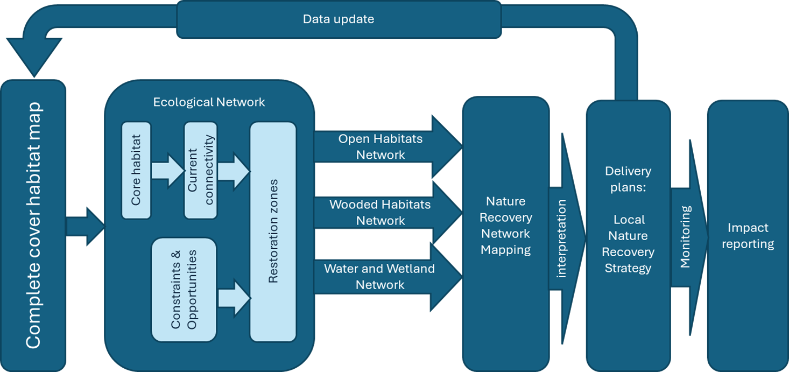

Figure 1: : From Ecological networks to a Nature Recovery Network and Local Nature Recovery Strategy: Flow chart showing the concept of how separate ecological networks are combined into a NRN, and the larger context and use of NRNs.

  - Caveats for use, and spatial scales
The Nature Recovery Network should be considered as an indicative aid to decision making. A guide to the areas where habitat restoration or enhancement would create the greatest benefit to increase the connectivity and resilience of the existing network. It is generated from modelling of best available data and may not always reflect the true picture on the ground, therefore advice on interventions should always be sought from suitably qualified experts. Care should always be taken to prevent degradation or further isolation of any existing valued habitat.
The NRN mapping is based on ecological needs, therefore there will be other constraints that need to be considered alongside the NRN when site interventions or projects are being planned, such as the local historic environment record, strategic infrastructure and obviously landowner and occupier engagement and permission.
The NRN has been mapped with a view to balancing the need to view it at a county scale while still being useful to guide project planning at a site level. If each individual priority habitat type (up to 56 in England) is mapped as a separate network and overlayed, it is so complicated a map that it makes interpretation and decision making extremely difficult. In order to achieve a better balance of information and ease of interpretation, habitats have been grouped into different functional systems (Ecological Networks) based on the National Ecosystem Assessment groupings. The three Ecological Networks and the habitats considered core habitat for each network are given in table 1.
Table 1. Habitats considered as core for each Ecological Network
Ecological Networks | Core habitats
Open Habitat Network | All priority* habitat grasslands and heathlands
Woodland Network | All broadleaved semi-natural or mixed mainly broadleaved semi-natural or broadleaved ancient woodland
Wetland Network | All priority* freshwater waterbodies and wetland habitats
*Priority habitats are those listed in Section 41 of the Natural environment and Rural Communities Act 2006.

In the modelling, Open habitat and Woodland are presented as a single continuous layer by using a conditional decision tree to decide whether a location is a higher priority for “Open habitat” or “Woodland”, or of equal priority “Open or Woodland habitat” in which case a matrix habitat may be of benefit. The “Open or Woodland habitat” areas are an indication of where the Open and Woodland networks cross and care should be taken not to cut off the connectivity of one network with the other, e.g. dense woodland planting could cut off the Open habitat network, but Traditional Orchard or Wood Pasture or grassland with scattered scrub or woodland with wide rides and glades could provide benefits for both networks at the crossing point.
Traditional Orchard, and Wood Pasture and Parkland, though priority habitats in their own right, are not considered core habitats, but they are important elements in the Open and Woodland networks due to their very high assigned permeability for those networks.
The Wetland Network layer is provided as a transparent overlay. Where it crosses the Open habitat network there could be opportunities for fen type habitats. Where it crosses the Woodland network there could be opportunities for wet woodland.
  - Species specific needs
The NRN focusses on restoration and connectivity of habitats, this will be of benefit for the majority of species, however, there will be some species which have more specific requirements and need species specific targeted actions to help them to be more resilient or recover. These requirements are not mapped in the NRN but are mapped as additional species layers in the Local Nature Recovery Strategy Mapping of which the NRN forms a part.

Complete cover, habitat base layer

Creating the Gloucestershire, plus 3km buffer, habitat layer

For the first draft of the NRN (GlosNRN_v1.2Beta) a rough landcover layer was produced in 2019 for Gloucestershire plus 2km buffer (seen Annex 1 for details). A more accurate updated version of the Gloucestershire (plus 3km buffer) complete cover habitat inventory map was created in 2023 using the following method.

The Ordnance Survey Master Map (OSMM) topographical (polygon) layer was used under PSGA licence as the base polygons into which to attribute the best available habitat data, using the UK Habitat Classification System Version 2 (UKHabs) codes (Butcher et al. 2023), for the county of Gloucestershire plus a 3km buffer. The buffer ensures that the cost distance model can look for connectivity outside of the county so that the connectivity is correct at the border, for this reason all final layers should be clipped back to the border. The data sources used to compile the habitat layer are detailed in Table 2.

Data processing
Some data clean-up was initially required to remove any overlaps and invalid geometries.

The source datasets used different habitat classification systems. To standardise these differing classification systems, all habitat classifications were converted to UKHabs version 2, adding a primary code and secondary code(s) (if applicable) to each polygon in all data sources.

The OSMM polygon layer forms the base polygons into which to attribute the best available habitat data. Rasterized versions of the layers in Table 2 were matched to the OSMM polygons by using a conditional query based on perceived dataset reliability and data age to compare overlapping survey data and assign the most accurate likely land use which covers at least 40% of the OSMM polygon to each polygon. 40% polygon coverage is used as the lower limit as sometimes the Priority Habitat Inventory polygons are smaller that OSMM polygons. It is better that we record the possibility of Priority Habitat and then adjust the coverage with ground truthing survey rather than exclude the record. All built-up areas, roads and water related features were attributed directly from OSMM.

UKCEH Land Cover Map 2019 was used to fill gaps where no other habitat data was available.

Table 2. Habitat data sources and reliability score
Dataset | Dataset lookup | Reliability score (1=most reliable) | Licence
National Trust Habitats Phase 1 GB | NT_GB | 1 | NT permission
Validated Combined Phase 1  2006 - 2018 v8 | ValComb_P1H | 2 | GCER permission
Wye Valley Phase 1 –  Herefordshire | P1H_WV_H | 2 | Wye Valley NL permission
Herefordshire Phase 1 | P1H_H | 2 | HBRC permission
Wales Phase 1 Vegetation | P1H_Veg_Wal | 2 | OGL
Natural England Traditional  Orchards | TOI_Eng | 3 | OGL
Natural Resources Wales  Traditional Orchards | TOI_Wal | 3 | OGL
Worcestershire Habitat  Inventory - Gloucestershire | WHI | 5
Natural England Priority  Habitat Inventory (JP  Classifications combined) | PHI_Central | 6 | OGL
National Forest Inventory  England | NFI | 9 | OGL
National Forest Estate  sub-compartments | NFE | 9 | OGL
Natural England Countryside  Stewardship Scheme Management  Options | CSO | 10 | OGL
Natural England Environmental  Stewardship Scheme Options | ESO | 10 | OGL
Gloucestershire City Green Spaces:  - Allotments  - Playing Fields | GCGS | 10 | Glos City Permission
Stroud District Council  Green Spaces:  - Green Spaces | SDC_GS | 10 | Stroud DC permission
Cotswold District Council  Open Spaces:  - Allotments  - Amenity Green Space  - Cemeteries and  Churchyards  - Local Green Space  - Playing Fields  - Sports Grounds | CDC_OpenSpace | 10 | Cotwold DC Permission
Forest of Dean District Council Ownership | FOD | 10 | FoDDC permission
UKCEH Land Cover Map 2019 | LCM | 12 | Non business use
Natural England Ancient  Woodland Inventory | AWI_Eng | 13 | OGL
Natural Resources Wales  Ancient Woodland Inventory | AWI_Wal | 13 | OGL
Natural England Wood  Pasture and Parkland Inventory* | WPP  (MB_ManualEdit) | 14 | OGL
* Wood Pasture and Parkland correction
For the creation of the main NRN habitat layer, the Wood Pasture and Parklands (WPP) layer was originally ranked too highly in terms of its reliability. As such, in some instances, polygons were assigned the full habitat code of g_27. However, upon analysis of the main habitat layer against other datasets and satellite imagery, it was clear that some of these polygons should have been assigned a different habitat code. For example, some polygons in areas of woodland had been given the habitat code g_27 instead of the relevant woodland habitat code. This error was due to the WPP layer out-ranking other datasets which are, in fact, more reliable. To resolve this, polygons previously coded using the WPP layer were recoded using the next most reliable dataset. In the habitat layer, the “Dataset” column indicates which polygons have been corrected. It contains the name of the dataset used to recode the habitat, followed by “(WPP correction)”.

Details on work done to the layers in this table to prepare them to be used in the python script were recorded in a working data spreadsheet.

This 2023 updated iteration has produced a more accurate Gloucestershire (plus 3km buffer) complete cover habitat inventory map, based on Ordnance Survey Master Map (OSMM) topographical (polygon) layer. The OSMM polygon layer forms the base polygons into which to attribute the best available habitat data. Rasterized versions of the layers in table 2 were matched to the OSMM polygons by using conditional query based on perceived dataset reliability and data age to compare overlapping survey data and assign the most accurate likely land use which covers at least 40% of the OSMM polygon to each polygon. 40% polygon coverage is used as the lower limit as sometimes the Priority Habitat Inventory polygons are smaller that OSMM polygons. It is better that we record the possibility of Priority Habitat and then adjust the coverage with ground truthing survey rather than exclude the record.

Once the initial habitat map had been produced through running the first python script, we then had to manually insert some additional datasets to the layer because they contained newly surveyed up-to-date ground-truthed habitat data which often had different boundaries to the OSMM data. These datasets and the order in which they were inserted into the habitat layer are listed in the table below.

Table 3. Manually inserted habitat data
Additional Dataset | Dataset lookup | Insertion order (1 = first; the most-reliable datasets were inserted last) | Licence
GWT Habimap Data | GWT_Habimap | 11 | GWT-owned data
Farming and Wildlife Advisory Group habitat data | FWAG | 11 | Permission to share with GWT
Nature Space Partnership Ponds | NSP_Ponds | 10 | Nature Space agreement
Living Record Foresters Forest ponds | LRFF | 12 (inserted last but avoided overlaps with above layers)
GWT Ashleworth habitat data | GWT_ASH2020 | 9 | GWT-owned data
Floodplain Meadow Partnership NVC Ashleworth | FMP_ASH | 8 | Permission to share with GWT
GWT Elmore habitat data | GWT_ELM2020 | 7 | GWT-owned data
Countryside Stewardship Woodland Creation Edits (manual fine tuning of planted area) | CSWC | 6 | OGL
GWT Canal UKHab habitat survey parcels | Canals_HSP | 5 | GWT-owned data
GWT Canal Phase 1 habitat data | Canals_P1H | 4 | GWT-owned data
Cleeve Common data for habimap | CC_combo | 3 | GWT-owned data
Cleeve Common Natural England Field Unit NVC mapping | CC_NEFU | 2 | OGL
ARUP Phase 1 survey of A417 area | ARUP_A417 | 1 | Public access data

Note on data cleaning of final habitat layer – geometry issues were resolved as much as possible through using the validity check tool and the geometry fix tool where appropriate in QGIS, ensured there were no multipart polygons. Where habitats were coded as NULL due to the OSMM polygon being smaller than 1 pixel in the LCM layer, they were re-coded manually depending on either the LCM layer or the OSMM layer, whichever was most detailed.

Since all semi-natural broadleaved woodland including mixed mainly broadleaved was included as core woodland habitat, any polygon coded as woodland ‘w1’ or ‘w1_’ in final habitat layer needed to be further resolved to determine whether they were w1h5 (mixed mainly broadleaved [included as core habitat]) or w1h6 (mixed manly conifer [not included as core]). NFI, LCM, FE and OSMM filtered on conifer woodland areas were used to check, using the overlap analysis tool which, ‘w1’ or ‘w1_’ habitats overlap with conifer woodland areas by 40% or more and these polygons were re-coded as ‘w1h6’. the dataset label for these polygons has been changed from the original dataset from which the data was extracted, to ‘MB_manualEdit_w1h6’.

Ecological network connectivity

Open habitat, woodland and wetland ecological networks connectivity
As mentioned above, the multitude of habitats were grouped into three ecological networks to enable easier interpretation of the maps. Connectivity for three of the networks (open, woodland and wetland) was modelled using cost distance analysis.

The original Forest Research methodology (Watts et al 2021) upon which this was based, used generic focal species. A generic focal species is described in Eycott et al (2007) as “a conceptual species, whose profile consists of a set of ecological requirements reflecting the likely needs of real species …… should encompass the needs of most (but not all) real species that need to be considered in the landscape plan or evaluation”. These are model species for which you set parameters of minimum viable patch area and dispersal distance.

Invertebrate and vascular plants have been shown to show the most significant responses to patch size and dispersal distance (box 1).

Box 1
Humphrey et al 2015 – carried out a research review, grouped studies on organisms into 4 groups: vertebrates, invertebrates, vascular plants and cryptograms (lichens, bryophytes, fungi).
• Significant response to patch area was highest in studies of invertebrates 69% and lowest in vascular plants 57%.
• Patch characteristics (structure/condition) important for all groups.
• Ecological continuity (connectivity) most sig for vascular plants 88% > Inverts 67% > vertebrates 60% > cryptograms 38%.

However, the data available in the research literature for minimum viable areas (MVA) (and dispersal distances for that matter) is very sparce. Rather than guessing at MVAs, we took the approach that using incremental dispersal distances in 500m bands outwards from the existing habitat patches would be a proxy for different levels of connectivity for different mobilities of species. This also reflects the Lawton principles, i.e., expanding outwards from existing good quality habitat.

The principle of examining connectivity by cost distance modelling is that each habitat category on the habitat layer is given a cost (permeability) score, this is an estimated cost to movement for the model species moving across that habitat or land use. For example, a high cost of 50, which we would give to buildings and sealed surfaces, means it has very low permeability to species movement. A low cost of 1 has a high permeability to species movement. The core habitats are given a cost equivalent to zero as they provide all the needs for the species. The cost is used to adjust how far the generic species would move into the landscape from a core habitat patch, so for a model species with a maximum dispersal distance of 500m, the distance it will actually move out into the landscape is calculated as dispersal distance divided by cost. This means that for a high cost habitat like concrete, we divide 500m by 50 = movement distance of only 10m across that surface.

Assigning core habitats and cost (permeability) scores
Priority habitats were grouped into three ecological networks: open habitats (grassland and heathland), woodland habitats and wetland habitats.

Least cost distance analysis (in ArcGIS Pro) was used to model current network connectivity. Each UKHabs code present in the habitat layer was assigned a cost (permeability) value (see table 3a - c) for each of the 3 networks and for each network the UKHabs code classed as core habitats were identified. Cost (permeability) scores were based on work done by West of England Nature Partnership (WENP) and Somerset Wildlife Trust with Kevin Watts at Forest Research. The assignment of the relevant UKHabs codes to each ecological networks and their associated cost/permeability was recorded in a CSV file.

For the least cost distance analysis, core habitat patches 10m or less apart were considered to be contiguous and were merged into a single patch.

Table 3a*. Permeability scores assigned to habitat/land-use for ecological networks: Open habitat network

Permeability level |  | cost score | Open Habitats network
Full permeability (core habitat) |  | 0 | Unimproved neutral/Calc/acid grassland (g1a, g2a, g3a), lowland/upland heathland, moor, PMGRP
High permeability | semi-improved grasslands; high floral species richness, relatively unmodified with strong vertical structure and known to readily accommodate grassland/heathland species, largely unshaded | 1 | Semi-improved neutral/calc/acid grasslands including other neutral grasslands (g3c), g2 and non priority habitat heathland h1, open mosaic on previously developed land u1a.
Medium permeability | semi-natural habitats; little  modification with some vertical structure, lower floral species richness narrow species rich strips or open treed habitats | 5 | conservation road verges, traditional orchards, WPP, Allotments, bracken, Hedgerows, line of trees, poor quality other neutral grasslands g3c5, g3c7, g3c8, unknown quality acid or neutral grasslands (g3, g1 - g2 is covered above because handled differently in UK hab)
Medium permeability | little modification but with limited vertical  structure, wet conditions, very dry or heavy shading | 7 | Fen marsh & swamp, mire, bog (any f) broadleaved woodland, mixed woodland (unless specified w1h6 or w1 newly planted/felled), dense scrub, tall herb,
Medium permeability | moderate modification, limited structure and limited floral species richness, heavy shading | 10 | Coniferous woodland (any w2), mixed mainly coniferous woodland w1h6 or w1 newly planted/felled, fields with arable margins
Low permeability | Heavily modified habitats with very little  structure | 20 | Modified (g4) and amenity grassland; leys; unknown grassland type not already assigned (g) ; arable and horticulture (without margin specified); intensive orchards, open water; gardens, non native scrub, Landfill, rock, sparsely veg land; bare ground; winter stubble; u1d or u1 with 26 or 827
Low permeability | Artificial and hostile habitats | 50 | Roads; buildings

Table 3b*. Permeability scores assigned to habitat/land-use for ecological networks: Woodland habitat network.
Permeability level |  | cost score | Woodland network
Full permeability (core habitat) |  | 0 | Broadleaved ASNW (from national inventory) including broadleaved PAWS (from national inventory), all broadleaved priority habitats or Annex 1 habitats, all broadleaved semi-natural woodland: all w1 (or w1g)_28, w1_30 or w1_28,30 or w1_28,29 (broadleaved plantation on ancient woodland site) - but not g_28 (incorrect assignment of codes). Any patches less that 0.25ha (the minimum size used in the new Ancient Woodland Inventory updates) were excluded from core habitat to prevent dilution of the network with the many tiny woodland patches.
High permeability | Secondary woodland and woodland-like habitats; relatively unmodified with strong vertical structure and known to readily accommodate woodland species | 1 | new planted/felled semi-nat broadleaved and mixed woodland; Traditional orchard; wood pasture & parkland - w1 (with no 28 or 30), w1h, WPP (g_26 plus woodland code) or (w_26) or 26, 32 otherwise could just be historic parkland boundary looking at way codes have been applied. u1 with 28,30 or 30 or 28,29.
Medium permeability | Unimproved semi-natural habitats; little  modification with some vertical structure | 3 | hedgerows; heathland; dense scrub; scattered trees; remnant traditional orchards, Line of trees. Includes h1
Medium permeability | Unimproved semi-natural habitats; little  modification but with limited vertical  structure | 5 | Unimproved grassland (g1a, g2a, g3a), bracken (g1c), marshy grassland (g+ plus 502 or 503 or 14 or 15, swamp, fen, bog, mire (f), tall herb (16), scattered scrub (10)
Medium permeability | Semi-improved habitats; moderate  modification and limited structure | 10 | unknown or coniferous woodlands inc planted/felled (all "w" or w2), semi-improved grassland (above just g but not unimproved), bush orchards, allotments, u1 with 827 (to allow woodland network opportunity in urban gardens)
Low permeability | Heavily modified habitats with very little  structure | 20 | unknown (g), modified and amenity grassland, arable and horticulture (and c), water, gardens, rock, field with arable margins; ruderal; landfill; bare ground, u1d
Low permeability | Artificial and hostile habitats | 50 | Roads; buildings,

*Reproduced and modified from work done by West of England Nature Partnership (WENP) and Somerset Wildlife Trust (SWT) with Kevin Watts at Forest Research (FR). Wetland was not included in work done by WENP and SWT/FR. The Wetland costs have been developed using the principles of structural complexity used above.

Table 3c. Permeability scores assigned to habitat/land-use for ecological networks: Wetland habitat network.
Permeability level |  | cost score | Wetland Network
Full permeability (core habitat) |  | 0 | wetland habitats (NERC duty priority habitats)
High permeability | Flood zone 2 | 1 | any semi imp grassland (g1,g2,g3 or above) or heath (h1 or above) or other priority habitats within flood zone or wet (must have one of these secondary codes 25 or 502 or 503 or 419), wet woodland, other wet habitats (non priority f habitats and r habitats)
Medium permeability | semi-improved grasslands; high floral species richness, relatively unmodified with some vertical structure and shading/damp areas ; semi-natural habitats; | 5 | Semi-improved neutral/calc/acid grassland including other neutral grassland (g1d, g2, g3c), dwarf shrub heath (h1), other (non water/wetland) priority habitats without the wet secondary codes above (excluding woodland)
Medium permeability | lower floral species richness narrow species rich strips or open treed habitats | 7 | conservation road verges, traditional orchards, WP&P, Allotments, bracken, tall herb, Hedgerows, line of trees, unknown quality grasslands (g3, g1), unknown grassland (g) with wet secondary code as above.
Medium permeability | moderate modification, limited structure and limited floral species richness, heavy shading | 10 | non-wet broadleaved woodland or mixed mainly broadleaved, dense scrub, bracken
Low permeability | Heavily modified habitats with very little  structure, very dry | 20 | arable and horticulture (all c incl any parkland or trad orchards on cropland), modified grassland (g4), coniferous woods, coastal veg shingle, gardens, u1d or u1 with 26 or 827
Low permeability | Artificial and hostile habitats | 50 | hard surface, built environment, bare ground

Open habitat network and woodland network restoration zones

Assigning Open Network and Woodland Network opportunities and constraints
Opportunities and constraints were identified for each of the open habitat and the woodland ecological networks (Table 4a-b) and spatial layers produced for each of these. Weightings were applied to each layer and the layers combined to produce two network opportunity scoring layers, one for open habitat and the other for woodland.

Table 4a. Opportunity and constraints layers for the open habitat networks.
Layer | Rationale | Constraint or opportunity | Weightings
Open habitat cost distance output | Weighting of least cost pathway distance from core habitat patches | opportunity | 1 through 500 = 10  501 through 1000 = 8  1001 through 1500 = 6  1501 through 2000 = 4  2001 through 2500 = 2  All other values = 0
Agri land classification - Open Network | Grade 1 and 2 land prioritised for food production | Graded opportunity* | Grade 1 = 1  Grade 2 = 2  Grade 3 = 3  Grade 4 = 4  Grade 5 = 5  Urban = 1  Non-Agricultural (0 in ALC)= various depending on landuse:  - Water Park areas = 1  - Rodborough common and airfields = 3  - Everything else (mainly woodland) = 1
All semi natural open habitats (all g1,g2,g3,h1 and h3 UKHAB codes from habitat layer) | Restoration opportunity of permanent grassland not currently priority habitat quality | opportunity | 5
Land within 500m of existing core open habitat | Open habitat smaller and more fragmented patches so need to concentrate high priority very close to existing patches | opportunity | 5
Heritage sites – Scheduled ancient monuments and battlefields | Heritage sites can be protected with grassland habitat, do not want woodland | opportunity | 5
PAWS (from Ancient Woodland Inventory) | PAWS should be restored to seminatural broadleaf | constraint | 0
Existing priority habitats extracted from habitat layer using codes in PriorityHabs.csv** | Existing priority habitat should remain as is | constraint | 0
all 'r' (water) and 't' (coastal/marine) habitats | Counted them as constraints because otherwise the model was picking up parts of the river Severn as opportunity areas for woodland and open networks | constraint | 0
*changed these gradings so that nothing is graded 0. Urban =1, Water Park areas = 1. This is because some areas which were covered by ALC grade 0 polygons were not also covered by other opportunity layers, and were not covered by any constraints layers. So large areas of urban and water habs were being calculated as low opportunity areas when actually there isn't really an opportunity there at all.
**removed all arable field margin habitat codes from the PriorityHabs.csv so that they are not counted as priority habitats and not counted as a constraint to restoration. Often the whole field or land parcel was assigned 'c1a%' which meant that a whole parcel of land was being counted as constraint but actually the habitat code is just referring to the margin and not the whole field.

Table 4b. Opportunity and constraints layers for the woodland habitat networks.
Layer | Rationale | Constraint or opportunity | Weightings
Woodland cost distance output | Weighting of least cost pathway distance from core habitat patches | opportunity | 1 through 500 = 10  501 through 1000 = 8  1001 through 1500 = 6  1501 through 2000 = 4  2001 through 2500 = 2  All other values = 0
Agri land classification – Wood Network | Grade 1 and 2 land prioritised for food production | opportunity | Grade 1 = 1  Grade 2 = 2  Grade 3 = 3  Grade 4 = 4  Grade 5 = 5  Urban = 1  Non-Agricultural (0 in ALC) = various depending on landuse:  - Water Park areas = 1  - Rodborough common and airfields = 1  - Everything else (mainly woodland) = 3
Land within 1000m of existing semi natural woodland | There are more larger woodland patches than open habitat patches so 1000m means woodland restoration is slightly more widely spread than open restoration. | opportunity | 5
PAWS (from Ancient Woodland Inventory) | PAWS should be restored to seminatural broadleaf, some may already be broadleaf plantation | opportunity | 1
Heritage sites – Scheduled ancient monuments and battlefields | Woodland likely to damage heritage sites | constraint | 0
Existing priority habitats. Extracted from habitat layer using codes in PriorityHabs.csv | Should not create woodland on existing priority habitat, should remain as is | constraint | 0

Open network and woodland network combined opportunity/priority layer
Having created separate open habitat network opportunity scoring and woodland network opportunity scoring layers as set out above, a combined open & woodland network restoration zone prioritization layer was then created by using conditional statements to decide which of the two networks took priority or whether they were of equal priority and some form of matrix habitat was more appropriate. This helps the user consider where open and woodland networks intersect and should reduce the risk of cutting one network off with the other.
The individual ecological network scoring layers were divided into 3 categories (High, Med, Low) by identifying the 2 break points in the opportunity scores that sit at the threshold between high and med, and med and low, as follows. The percentage areas are approximate as the opportunity layer is discrete not continuous, the algorithm picks the closest break point in the scores once the target area has been reached:
- High opportunity/priority - The High opportunity/priority category comprises approximately 20% of the area of the opportunity layer (starting at the maximum opportunity score and adding lower scores in turn).
- Medium opportunity/priority - are the opportunity scores that comprise approximately the next 10% of area, starting at the high opportunity category minimum and working lower.
- Low opportunities comprise all other categories (approximately the remaining 70% of the area).
The core habitat plus high and medium categories therefore add up to 30% cover. This target value is based upon research which suggests that once 30% cover is reached most random habitat patches are in close proximity to another (Buckley and Fraser 1998, Andren 1994).
This combined layer shows potential opportunities with prioritization based on working outwards from existing habitat patches. It also helps to ensure that existing priority habitat is not inadvertently destroyed by for example woodland creation on priority grassland.
The output raster categories are defined in Table 5.
Table 5. Classification of opportunities for combined opportunity layer.
Q1 | Raster category
Open or woodland network high priority | 11
Open network high priority | 10
Woodland network high priority | 9
Open or woodland network medium priority | 8
Open or woodland network low priority | 7
Woodland network medium priority | 6
Woodland network low priority | 5
Open network medium priority | 4
Open network low priority | 3
No opportunities (other priority habitats) | 2

The Wetland Network
The Wetland Network has been modelled differently and is largely based on topography and soil drainage type. The methodology was created following discussion with staff at the Wildfowl and Wetlands Trust, Slimbridge.
The data layers 1 to 5 (Table 6) were combined. Annex 2, shows the QGIS graphical model and the technical detail used to create the V2 wetland opportunity layer. In summary, anything in Floodzone 3 is included as an opportunity. For the areas outside of Floodzone 3, areas of impeded drainage or naturally wet soils plus high (>10) TWI are included as an opportunity. Any areas of peat are included as an opportunity, but any slopes >10 degrees are excluded.
The wetland network is provided as a transparent overlay. Where it crosses the Open habitat network there could be opportunities for fen type habitats. Where it crosses the Woodland network there could be opportunities for wet woodland.
Prioritization could, if desired, then be assigned by incorporating the Wet Network connectivity at, for example, 500m, 1000m and 3000m cost distance.

Table 6. Data layers for Wetland network opportunities V2 method
Data Layer | Constraint or opportunity | Use
1 EA Floodzone 3 | Opportunity | Inclusion if in floodzone
2 Topographical wetness index* (a useful indicator of soil moisture (Raduła et al 2018) and is a function of both the slope and upstream contributing area) | Opportunity/constraint | If High TWI (>=10) and poorly drained soil then inclusion
3 Natural England Peat Map 2025 | Opportunity | Inclusion of all peat
4 NATMAP: Soil drainage = ‘naturally wet’ or ‘impeded drainage’ | Opportunity/constraint | If High TWI (>=10) and poorly drained soil then inclusion
5 Slope (degrees) | Constraint | If slope >10 the exclusion
6 Wetland connectivity (cost distance) | Prioritization, can be applied following creation of the opportunity areas | 500m  1000m  3000m
*see Annex 2 for detail

Watercourses and open water bodies
Running and open water were not incorporated into the wetland network as different suits of species use them. Opportunities for watercourses and open water have not been created as existing mapping is available, such as priority pond mapping from the Freshwater Habitats Trust. Depending on what you want to achieve for a particular suit of species, you might target areas of low density to increase connectivity across the landscape, or areas of high density to create a larger surface area of water to support bigger more resilient populations.
Physical river connectivity is reliant on the removal of barriers. The Environment Agency have a barrier layer which incorporates prioritization for removal. This layer can be used in the first instance and local upstream prioritization can be added to it. Alternatively you could take the policy that any opportunity to remove a barrier should be taken as removal of any barrier will help internal river system movement even if it does not enable source to sea movement.

Farmland birds
While the Open, Woodland and Wetland networks support a wide range of species, they don’t cover the needs of species that use arable farmland e.g., arable plants and some of the farmland birds, particularly those relying on seed for food and those that nest in cropland. Having examined the farmland bird species, they distilled down into two groups: ground nesting species and Hedge/scrub/tree nesting species. In general, the adults utilise seed as their main food resource and an insect resource is required for the chicks. The farmland bird layers look at the availability of gari-environment scheme options to meet the nesting, adult, and chick food requirements of these two groups of farmland birds.

Farmland bird data extraction and interpretation
All live Environmental Stewardship Scheme (ESS) options and Countryside Stewardship (CS) options for Gloucestershire plus 3km buffer were downloaded from data.gov in June 2024. Natural England ESS farmland birds advisory note (Delivering the HLS Package for Farmland Birds 2013) and RSPB farming advice guidance from RSPB.org.uk was used to identify which options contributed to the following Arable Network benefits:
- Ground nesting sites
- Hedge/scrub/tree nesting sites
- Seed food source (adult food)
- Insect food source (chick food)
The ESS and CS point data was merged and the four Arable Network benefits were assigned to each option.
Ground nesting options and hedge/scrub/tree nesting options were extracted into two separate point data sets. A 1000m radius buffer was added to each of these data sets (based on foraging distances for birds e.g. Evens et al 2018).
Two layers were then extracted, adult food options points and chick food option points from the ESS, CS merged options layer.
For each nest buffer, the QGIS tool “Count points within polygons” was run for adult and then chick food.
The output from the above step was run through the QGIS tool “join by location summary” (apply sum of the “quantity” field) to get total area of adult food (af) and chick food (cf) options in each buffer.
Next the % area that the options cover per buffer was calculated. 7% of buffer area was used as the threshold for meeting the requirements (7% per holding was requirement under NE Farmland Birds: Advisory Note). Fields were then added to the attribute table for: percent af options, percent cf options (314.16ha total area of 1000m buffer so 100/314.16 x option hectarage = % area of the 1000m radius circle). Also added fields for af requirements met; cf requirement met; both af and cf requirement met; no requirements met (i.e., % area >=7), if met then coded to 1 if not met coded to 0.
The resultant output can then be separated into the following layers:
- Ground nesting birds – adult and chick food requirements met
- Ground nesting birds – adult food requirements met
- Ground nesting birds –chick food requirements met
- Ground nesting birds – no food requirements met
- Tree/Scrub/Hedge nesting birds – adult and chick food requirements met
- Tree/Scrub/Hedge nesting birds – adult food requirements met
- Tree/Scrub/Hedge nesting birds –chick food requirements met
- Tree/Scrub/Hedge nesting birds – no food requirements met
The areas where only one food requirement has been met are a high opportunity for enhancing the arable network.

Other species layer for the LNRS
A separate methods document is available that includes methods for the creation of the additional suite of layers for the Local Nature Recovery Strategy species measures (Public facing Map Layers methodology for Gloucs LNRS).

Metrics to assess coherence and resilience
Patch and network viability is not included within the LNRS, but is included as part of the Gloucestershire Natural Capital mapping website (https://gcerdata.com/naturalcapital/) for the purposes of project planning and design.

Patch Viability
Note that on the Gloucestershire Mapping website we have used the terms Patch Viability and Network Viability rather than talking about resilience and coherence and metrics as we think that viability is a more understandable term/concept for the layperson.

Open or Woodland Network Patch Viability - this is the area in hectares of each core habitat patch and can be used to consider whether patches meet minimum viable patch size requirements to
support particular species or groups of species. In general terms you do not want core patches
below the minimum threshold for the network and these are a priority to expand in size.

The Open Network Patch Viability patch size categories used are estimated from various studies:
- 1ha (invertebrates e.g. Hesperia comma, Hill et al 1996)
- 3ha (Somerset Ecological Networks Report 2016, estimate based on a range of species data)
- 5ha (large blue butterfly in Somerset Ecological Networks Report 2016 and Pe'er et al 2014)
- 30ha NERR081 for invertebrates of heathland
Many patches are below the 1ha minimum threshold and so will support a much reduced suite of species.

The Woodland Network Patch Viability patch size categories are taken from the Natural England Nature Networks Handbook (NERR081) which lists various examples of viable patch sizes for different species/groups associated with woodland (Box 2). The woodland core habitat patch size categories used in this layer illustrate those suggested thresholds:
- <1.5Ha
- 1.5 - 5Ha
- 5 - 10Ha
- 10 - 20Ha
- 20 - 100Ha
- >100Ha

Many patches are below the lower 1.5ha threshold and so will support a much reduced suite of species.

Box 2.
From NERR081 Nature Networks Evidence Handbook

How big should a wildlife site be? Studies that have suggested minimum areas to support populations of different taxa in woodland habitats.
• Herbaceous species: require > 1.5 ha and preferably > 5 ha to support typical woodland species (Usher et al. 1992); species richness increases to 40 ha (Humphrey et al. 2013)
• Bryophytes: require > 3.5 ha to support a diverse array of bryophyte functional groups (Humphrey et al. 2013)
• Saproxylic Beetles: with low dispersal abilities require > 100 ha (Humphrey et al. 2013)

• Birds: the species richness of woodland birds is maximised at > 10 ha (Bennett & Saunders 2010), but Marsh Tit Poecile palustris requires >25 ha and Great Spotted woodpecker Dendrocopos major > 100 ha (Peterken 2002)
o if < 1.5 ha, some woodland bird species will not breed (Hinsley et al. 1995)
• Mammals: the likelihood of dormice occupying a suitable woodland is maximised if the woodland is > 20 ha (Bright et al. 1994; Bennett & Saunders 2010)
o Red squirrels Sciurus vulgaris require > 10 ha (Peterken 2002)
• General: > 3 ha is required to provide some internal habitat heterogeneity, but >25 ha is required if the rides are to be open enough for open-habitat species (Peterken 2002).

Network Viability
Woodland or Open habitat network viability - This shows the summed area of core patches within each functionally connected wooded habitat network within a 500m cost distance (dispersal distance). If you have core patches that are part of a network within these layers, you can look at how resilient that network currently is. Does it meet the minimum threshold or is it below the threshold. If below the minimum threshold, this is a priority; you could increase the number of patches within this network (ensuring they are greater than the minimum viable patch area) or expand the area of existing patches. The NRN layer can help to show where expansion could take place to increase the overall resilience of the ecological network.

Open Network viability thresholds: The Southwest Naturemap methodology states that a viable metapopulation needs 10 x minimum viable patch area (from Cox et al (1994)), therefore the core patch area categories used in "Open habitat network core patch sizes" are multiplied by 10 to provide the categories used in this layer, except for 70ha which is the lower estimate for marsh fritillary butterfly given in the Somerset Wildlife Trust Ecological Networks Report 2016). The lowest category (<10Ha) are considered to be unviable networks.
- under 10ha of core open habitat
- 10-30ha of core open habitat
- 30-50ha of core open habitat
- 50-70ha of core open habitat
- over 70ha of core open habitat

Woodland Network viability thresholds: The NE Nature Networks Handbook (NERR081) recommends woodland wildlife sites should be at least 40ha and preferably 100ha in size. Here that is interpreted as total woodland core habitat within a functionally connected woodland network at 500m cost distance. Many of the networks are below the 40ha minimum threshold given for maximising the species richness of lower and higher woodland plants and vertebrates. 100ha is given as the threshold to support wider ranging species and those with specialist requirements.
- under 40ha of core woodland
- 40-100ha of core woodland
- over 100ha of core woodland

Identifying strategic restoration areas
The networks above concentrate on prioritizing work around the bigger, better principles of network restoration. I.e., the focus on expanding outwards from core habitat patches and reinforcing the core networks. The modelling does not prioritize connections across large gaps in the networks. These large gaps require a more strategic approach as they will require a lot more work and investment to bridge them. However, Local Nature Partnerships or other groups of partners may want to develop large projects to bridge such gaps. The following is a suggested way to approach this:
- Local expertise is required to identify strategic restoration areas as you need to consider things such as climate corridors that may go well beyond the county map. Decisions can be aided by looking at the NRN map which shows the bigger, better opportunities for the network.
- Identify extensive low opportunity areas between areas of high/medium opportunity.
- Overlay with the relevant network 5 or 10km connectivity layer, this will indicate least cost pathways.
- Overlay the relevant network patch and network viability layers to see whether there are stepping stones that could be enhanced within the gaps.
- Look for areas where the patch metrics fall below the lower thresholds.
- The needs of key species in particular locations may guide the identification of some strategic gaps.
- You may want to consider the location of local, national and European designations in relation to gaps.

ANNEX 1 – The original Gloucestershire complete cover habitat layer created for GlosNRN_v1.2Beta
For the first draft of the NRN (GlosNRN_v1.2Beta) a rough landcover layer was produced for Gloucestershire plus 2km buffer. Each constituent data set was translated to UK Habitat Classification. Fields were added for UKHabDesc (description), UKHabPrim (primary code) and UKHabSec (secondary code) where multiple CS options were located on a single field, the primary codes were listed with commas between them. Where more than one secondary code was relevant, these were again listed with commas between them. CEH Landcover 2015 was used as the basis and for each additional habitat data shapefile, a hole was clipped in the Landcover map using the survey data, then the survey data was joined to the clipped file. This was repeated starting with the oldest/least accurate survey data up to the most recent/accurate (table 2).

Table 2. Data sources used to create a complete cover habitat/land-use layer for Gloucestershire.
Insertion order | Data layer | Quality | Work needed | Licence
1 | CEH landcover map 2015 | Based on satellite data |  | Non business use
2 | National Forest Inventory (Broadleaved woodland categories) |  |  | Open Government licence
3 | National Forest Inventory (Coniferous woodland categories) |  |  | Open Government licence
4 | GWT Phase 1 data, Wye Valley AONB phase 1 data, Forest of Dean LAG Phase 1 data, National Trust Site Phase 1 Data | Ground truthed data |  | Agreed use within this project
5 | Priority Habitat Inventory - NE and GCER 2009 Lowland meadow and Trad Orchard updates to PHI (already contains Environmental Stewardship options data) | Theoretically high quality, but quite out of date. Not all field boundaries are aligned with MasterMap in all cases. Goes to units smaller than MasterMap polygons. | The no main habitat polygons had to be attributed with a primary habitat | PHI is Open Government licence,  GCER data agreed use within this project
6 | Countryside Stewardship 2016 options | Point mapped to centre-point of land parcel | Point data was joined to OS Master Map polygons | Open Government licence
7 | Ordnance Survey Master Map topographical layer | Roads  Inland water  Buildings  Gardens |  | Sub Contactors licence to Glos County Council

ANNEX 2 - Wetland network
Topographical wetness Index is a useful indicator of soil moisture (Raduła et al 2018) and is a function of both the slope and upstream contributing area.
Method used to Calculate topographical wetness index (now incorporated into the Python code), but in summary:
- Calculate slope from DEM in degrees
- Correct to remove zeros using raster calculator (“slope_degrees@1” <=0)*1+(“slope_degrees@1” >0)* “slope_degrees@1”
- Save as slope_degrees_modified
- Convert to radians – raster calculator “slope_degrees_modified@1”*0.01745
- Save as slope_radians
- Calculate upslope contributing area – using SAGA flow accumulation tool. Use the DEM file.
- Save as upslope_area
- Calculate topographic wetness – raster calculator ln((upslope area +1*(50*50)/tan(slope radians))

Updated methodology for V2 wetland opportunities (June 2024). Used DEM SO_SU_ST_SP (CRS 27700) to create a TWI using r.watershed tool (min size set to 500) in QGIS as SAGA tools no longer supported. Used r.reclass to set TWI score of 10 and above to 1 and polygonised that to create layer of TWI >=10.
Polygonised soil drainage of 5 to create Poorly drained soils layer.
Created polygon layer of slope >10.
Created graphical model to create the V2 wetland opportunity using the layers created above along with floodzone 3 (method as described in the table above except didn’t include the peat soils as though they would be included as drainage is 5, but not included because don’t overlap with high TWI as bog is on top of high ground. Need to merge peat in as final step using NE peat soils layer .

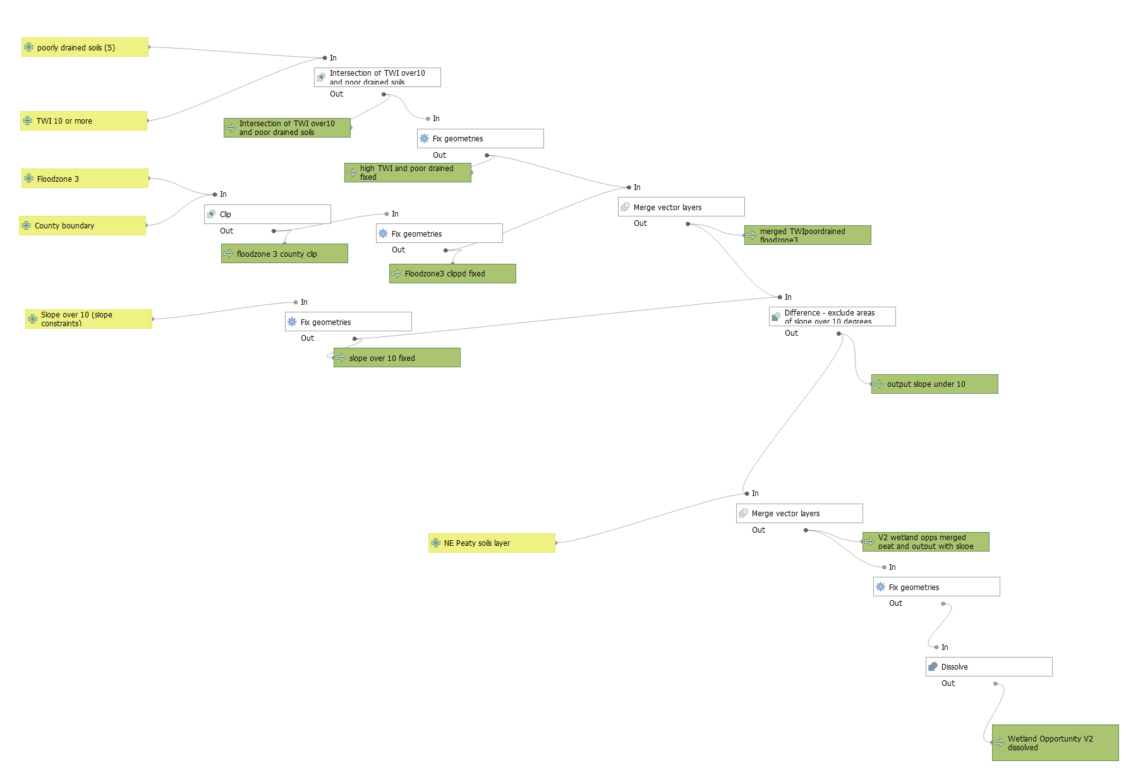
Wetland network V2 QGIS graphical model

ANNEX 3 – Python packages and GCER/GWT python scripts
Python scripts developed by GCER for running the NRN were created using Python 3.9.2 and the following packages:
Package | Version used (if available) | Description
numpy | 1.20.2 | Numerical python. This package is used primarily for array handling (particularly for raster data) but also some mathematical functions.
pandas | 1.2.3 | Python data analysis library. This package is used for handling data tables (particularly for the input and use of csv tables).
geopandas | 0.9.0 | A version of pandas that handles spatial data. Used for handling vector data.
rasterio | 1.2.1 | Raster input output. This package is used for handling raster data.
rasterstats | 0.14.0 | This package is used to carry out zonal statistics.
richdem |  | This package is used to carry out hydrological analysis and operations (slope and flow accumulation in particular).

Input files and python scripts used to produce the NRN are briefly described below. More detail on each output layer can be found in the associated metadata files:

GCER Location: D:\Dropbox\NRN

Permeability v1.9.csv
Description: A list (flat table) of all the UKHAB codes produced from the habitat layer creation of the NRN, their permeability score for each ecological network and their status (core habitat or not) within each network
Location at GWT: D:\Dropbox\NRN

PriorityHabs.csv
Description: A list (flat table) of all the priority habitat UKHAB

NRNEcoNetAssign.py
Description: A python script that takes the habitat layer and assigns each polygon a permeability value for each of 3 ecological networks, and whether it is core habitat for that network. It also produces rasters of this information.

NRNExtractOpportunities.py
Description: A python script that rasterises (2m resolution) all opportunity and constraint layers (resamples rasters to 2m where inputs are rasters).

NRNCalcCombOpps.py
Description: A python script that calculates opportunities for open and woodland networks, and the two combined.

ANNEX 4 – Flowchart of NRN modelling methodology
Same methodology used for Gloucestershire, Herefordshire and Worcestershire. Note that the Worcs process started at section 3.1 as Worcs supplied a habitat inventory.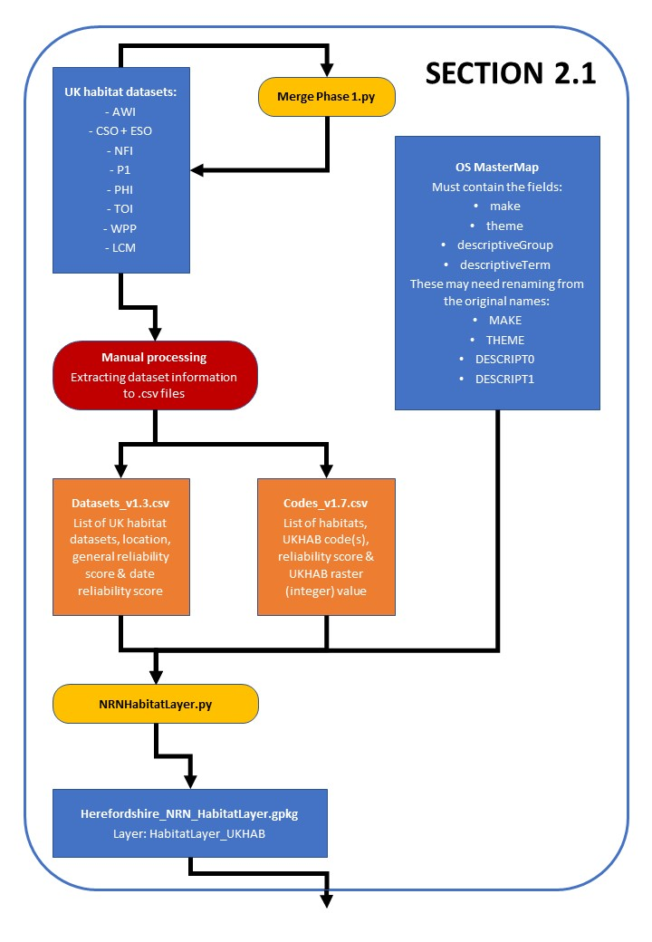
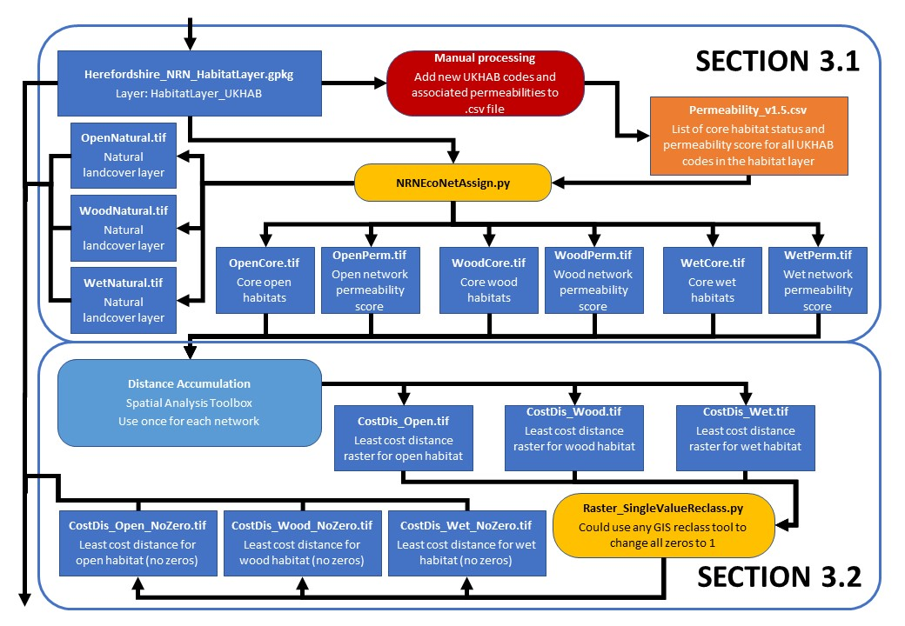
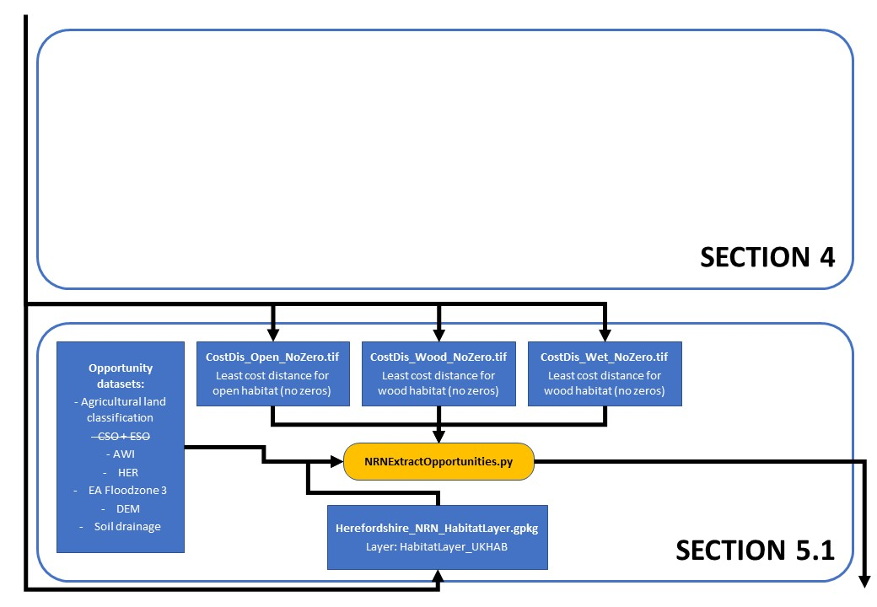

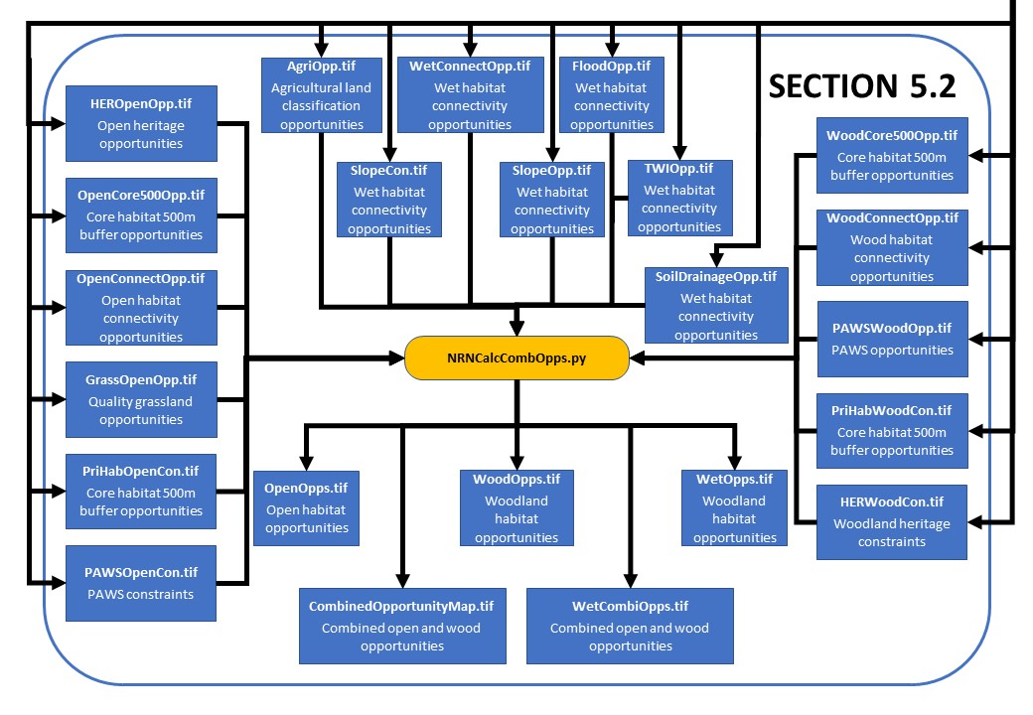

References
Andren, H. (1994), Effects of habitat fragmentation on birds and mammals in landscapes with different proportions of suitable habitat: a review, OIKOS 71: 355-366.
Barnes, R. (2016) RichDEM: Terrain Analysis Software. http://github.com/r-barnes/richdem

Bennett, A. F. & Saunders, D. A. (2010). Habitat fragmentation and landscape change. In Conservation Biology for All (eds N. S. Sodhi and P. R. Ehrlich), pp. 88–106. Oxford University Press, Oxford

Buckley, G.P. & Fraser, S. (1998), Locating new lowland woods, English Nature Research Report ENRR283.

Butcher, B., Edmonds, B., Treweek, J., Carey, P. and Norton, L. (2018) Introducing the UK Habitat
Classification – Updating Our Approach to Habitat Survey, Monitoring and Assessment. InPractice, 100. And UKHab Ltd (2023) UK Habitat Classification Version 2.0 (at https://www.ukhab.org)

Cox et al. (1994), Closing the gaps in Florida’s wildlife habitat conservation system. Forida Game and Fresh Water Fish Commission

Crick, H. et al (2020) Nature Networks Evidence Handbook, Natural England Research Report NERR081.

Evens, R., Beenaerts, N., Neyens, T. et al. (2018) Proximity of breeding and foraging areas affects foraging effort of a crepuscular, insectivorous bird. Sci Rep 8, 3008

Harris, C.R., Millman, K.J., van der Walt, S.J. et al. (2020) Array programming with NumPy. Nature 585, p357–362. DOI: 0.1038/s41586-020-2649-2.

Hill, C.D. et al, (1996), Effects of Habitat Patch Size and Isolation on Dispersal by Hesperia comma Butterflies: Implications for Metapopulation Structure, Journal of Animal Ecology, 65: 725-735.

Hinsley, S. A., Bellamy, P. E., Newton, I., & Sparks, T. H. (1995). Habitat and landscape factors influencing the presence of individual breeding bird species in woodland fragments. Journal of Avian Biology 26: 94-104.

Humphrey, J., Watts, K., Fuentes-Montemayor, E., Macgregor, N. & Park, K. (2013) The evidence base for ecological networks: lessons from studies of woodland fragmentation and creation. Forest Research, Roslin.

Humphrey, J. W., Watts, K., Fuentes-Montemayor, E., Macgregor, N. A., Peace, A. J., & Park, K. J. (2015). What can studies of woodland fragmentation and creation tell us about ecological networks? A literature review and synthesis. Landscape ecology 30: 21-50.

Pe'er, G. et al (2014), Toward better application of minimum area requirements in conservation planning, Biological Conservation 170: 92-102

Peterken, G. (2002) Reversing the habitat fragmentation of British Woodlands. WWF-UK, Godalming.

Phillips, J., Willmott, M. and Grice, P., (March 2013)Delivering the HLS Package for Farmland Birds: Advisory Note for Natural England advisers
Radula, M.W. et al (2018) Topographic wetness index explains soil moisture better than bioindication with Ellenberg’s indicator values, Ecological Indicators, 85: 172-179

RSPB farming advice guidance https://www.rspb.org.uk/our-work/conservation/conservation-and-sustainability/farming/advice/helping-species/

Somerset’s Ecological Network: Mapping the components of the ecological network in Somerset 2016, Somerset Wildlife Trust, Somerset County Council, Forest Research & Somerset Environmental Records Centre https://www.somerset.gov.uk/waste-planning-and-land/ecological-networks/

Southwest Naturemap Appendix 4: Stand-alone summary Primer on the Rebuilding Biodiversity methodology.

The pandas development team. (2020, March 18). pandas-dev/pandas: Pandas 1.20.2 (Version v1.20.2). Zenodo. http://doi.org/10.5281/zenodo.3715232

Usher, M.B., Brown, A.C. and Bedford, S.E. (1992) Plant-species richness in farm woodlands. Forestry 65: 1-13.

